WORKSHEET No.5
GRADE: X SUBJECT: CHEMISTRY NAME: DATE:
TOPIC:PERIODIC CLASSIFICATIONS
ANSWER THE FOLLOWING:
1. Lithium, sodium and potassium form a Dobereiner’s triad. The atomic masses of lithium and potassium are 7 and 39 respectively. Predict the atomic mass of sodium.
2. Chlorine, bromine and iodine form a Dobereiner’s triad. The atomic masses of chlorine and iodine are 35.5 and 126.9 respectively. Predict the atomic mass of bromine.
3. The electronic configuration of two elements ‘A’ and ‘B’ are 2, 8, 3 and 2, 8, 7 respectively. Find the atomic number of these elements. State the nature and formula of the compound formed by the union of these two elements.
4. The atomic number of three elements are given below:
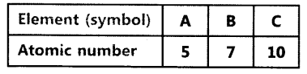
Write the symbol of the element which belongs to (o) group 13, (b) group 15, of the periodic table. State the period of the periodic table to which these elements belong.
5. The formula of magnesium oxide is MgO. State the formula of barium nitrate and barium sulphate, if barium belongs to the same group as magnesium.
6. Draw the structure of:
A. Hexanal b. Propanone
7. Draw the electron dot structure of (3)
a. Ethanoic acid
8. What is the functional group of the following:
a. acetic acid b. Butanal c. Pentanone d. Ethene
9. Name the following compound
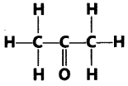
10. Name the products formed when ethanol burns in air. ‘
(ii) Write the balanced chemical equation for the reaction.
11. What is isomerism? Give an example.(2)
12.What is allotropy? What are the allotropic forms of carbon? (2)
13. Give the name of (2)
a. CH₃-CH₂-CH=CH-CH₂-CH₃ b. CH₃-CH₂-COOH c.CH₃-CH₂-CHO
d. CH₃-C=C-CH₃ e. CH3-CO-CH₂-CH₃
_{14.} What is the cause for permanent and temporary hardness of water? How will you remove the hardness of water?
15. Why carbon cannot form ionic compound?
16. The elements of the second period of the Periodic Table are given below:
Li Be B C N O F
(a) Give reason to explain why atomic radii decrease from Li to F.
(b) Identify the most
(i) metallic and
(ii)non-metallic element.
17. What are the criteria of Mendleev’s classification? (2)
18. The elements of the third period of the Periodic Table are given below:
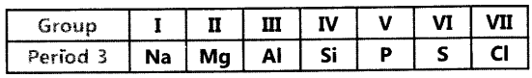
(a) Which atom is bigger, Na or Mg? Why?
(6) Identify the most (i) metallic and (ii) non-metallic element in Period 3.
19. Differentiate between combustion and oxidation.
20. How will you test the presence of ethanol and ethanoic acid by chemical method. Write the balanced equations for the reaction.
21. Why is diamond hard? Why is graphite a good conductor of electricity? (3)
22. Compound A undergoes oxidation to form compound B with molecular formula C₂H₄O₂, which combines with A to form C with molecular formula C₄H₈O₂. Identify A, B and C. Write the balanced equation for all.
23. Write a note on versatile nature of Carbon.(3)
24. What is homology? What are the importance of homology?(3)
25. What are the health hazards of alcohol? (3)
26. Atomic number of an element is 17.name the group and period, electronic configuration.
27. Two elements X and Y belong to group 1 and 2 respectively in the same period of periodic table. Compare them with respect to:
periodic table from the left to the right and why?
a. the number of valence electrons in their atoms
b. their valencies
c. metallic character
d. the sizes of their atom
e. formulae of their oxides
f. formulae of their chlorides
28. Na, Mg and Al are the elements having one, two and three valence electrons respectively. Which of these elements (a) has the largest atomic radius, (b) is least reactive? Justify your answer stating reason for each.
29. In the following table, are given eight elements A, B, C, D, E, F, G and H (here letters are not the usual symbols of the elements) of the Modern Periodic Table with the atomic numbers of the elements in parenthesis.
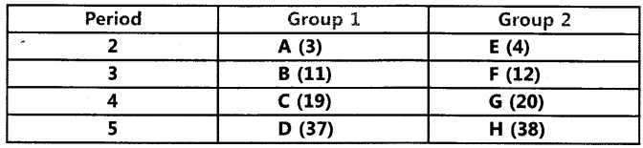
a. What is the electronic configuration of F?
b. What is the number of valence electrons in the atom of F?
c. What is the number of shells in the atom of F?
d. Write the size of the atoms of E, F, G and H in decreasing order,
e. State whether F is a metal or a non-metal.
f. Out of the three elements B, E and F, which one has the biggest atomic size?
30. What physical and chemical properties of elements were used by Mendeleev in creating his periodic table? List two observations which posed a challenge to Mendeleev’s Periodic Law.
31. Atoms of eight elements A, B, C, D, E, F, G and H have the same number of electronic shells but different number of electrons in their outermost shells. It was found that elements A and G combine to form an ionic compound which can also be extracted from sea water. Oxides of the elements A and B are basic in nature while those of E and F are acidic. The oxide of element D is almost neutral. Answer the following questions based on the information given herein:
a. To which group or period of the periodic table do the listed elements belong?
b. Which one of the eight elements is likely to be a noble gas?
c. Which one of the eight elements would have the largest atomic radius?
d. Which two elements amongst these are likely to be non¬metals?
e. Which one of these eight elements is likely to be a semi-metal or metalloid?
32. (a) Why did Mendeleev leave gaps in his periodic table?
(b) Give any three limitations of Mendeleev’s classification.
(c) In Mendeleev’s Periodic Table, why was there no mention of Noble gases like State d. Mendeleev’s periodic law. Helium, Neon and Argon?
(e) Would you place the two isotopes ‘ of chlorine, CI-35 and CI-37 in
different slots because of their different atomic masses or in the same slot because their chemical properties are the same? Justify your answer.
33. What are the merits and demerits of Mendeleev’s classification?(5)
34. In the following table, six elements A, B, C, D, E and F (here letters are not the usual symbols of the elements) of the Modern Periodic Table with atomic numbers 3 to 18 are given:
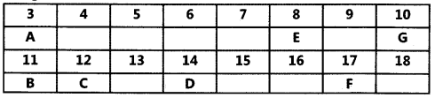
(a) Which of these halogen ?is (i) a noble gas, (ii) a halogen
(b) If B combines with F, what would be the formula of the compound formed?
(c)Write the electronic configurations of C and E.
35. What is the mechanism of soap on dirt.(5)
36. a. What are detergents chemically? List two merits and two demerits of using detergents for cleansing. State the reason for the suitability of detergents for washing, even in the case of water having calcium and magnesium ions.
b. What is the difference between the chemical composition of soaps and detergents?
c. Why are soaps not considered suitable for washing where water is hard?
37. (a) In tabular form, differentiate between ethanol and ethanoic acid under the following heads:
(i) Physical state (ii) Taste
(iii) NaHCO₃ test (iV) Ester test
(b) Write a chemical reaction to show the dehydration of ethanol.
38. What is an ‘esterification’ reaction? Describe an activity to show esterification with a neat diagram
39. Give 3 examples for Dobereiner’s traids. (3)
The position of three elements A, B and C in the Periodic Table is shown below:
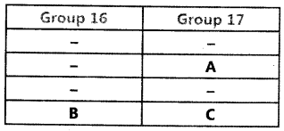
Giving reasons, explain the following:
(a) Element A is a non-metal.
(b) Element B has a larger atomic size than element C.
(c) Element C has a valency of 1
40. What are the demerits of Newlands law of octave? (3)
41. Write a note on group and period in the modern periodic table.(3)
